Siwa Wellness Resort Business Plan

# 1. Executive Summary

The Siwa Wellness Resort is a mid-range luxury retreat in Egypt’s Siwa Oasis, offering yoga and wellness retreats. Targeting group leaders and wellness influencers, the resort provides eco-friendly mud-brick huts, spa experiences, and curated cultural activities. The resort is designed to operate year-round, with strong revenue potential driven by advanced bookings and consistent group demand.

# 2. Vision & Mission

Vision: To be Egypt's premier destination for transformative wellness travel.

Mission: To provide a sustainable, authentic, and serene retreat space inspired by Siwa's heritage.

# 3. Concept & Design

The resort will feature 15–20 eco huts, a yoga deck, spa, natural hot spring, communal firepit, and organic dining. Design language incorporates ancient Egyptian motifs with minimalist luxury and local artisan work.

# 4. Target Market & Opportunity

Primary: Yoga instructors, spiritual coaches, mommy & me retreat leaders, health influencers. Secondary: Digital nomads, eco-tourists, tour operators. The growing wellness travel market presents a clear opportunity.

# 5. Site & Location

Located on 1.5 feddans (~1.55 acres) in Siwa with water, electricity, and licenses ready. Close to Oracle Temple, Salt Lakes, Cleopatra Spring, and the Great Sand Sea.

# 6. Service Model & Revenue Streams

Revenue includes group rentals, spa services, gift shop sales, and add-ons like meals and excursions. Outsourced facilitators bring guests while the resort handles hospitality and experiences.

7. Operational Plan

- Lean Core Team: Manager, kitchen/hospitality staff, housekeepers, maintenance

- Outsourced Roles: Retreat leaders bring their own guests and facilitators

- Local Anchor: Hesham acts as fixer, guide, operations support, and staff recruiter

- Spa Outsourcing: Collaboration with Hathor Natural Cosmetics for spa treatments using their products. Hathor will cover their own staffing costs.

- Seasonal Strategy: Lower capacity expected from June–September due to heat

Operational Expense Modeling

Monthly Staff Cost Estimate

To ensure conservative financial planning, all estimated monthly costs for food, amenities, and operational supplies are based on retail pricing from Amazon and Hyper One supermarkets in Egypt — totaling approximately 148,000 EGP/month.

However, upon launch, the resort will source from wholesale suppliers at significantly lower prices.

By modeling potential wholesale savings of 20% to 30%, monthly operational costs could drop to 118,400–103,600 EGP, reflecting savings of up to 44,400 EGP/month.

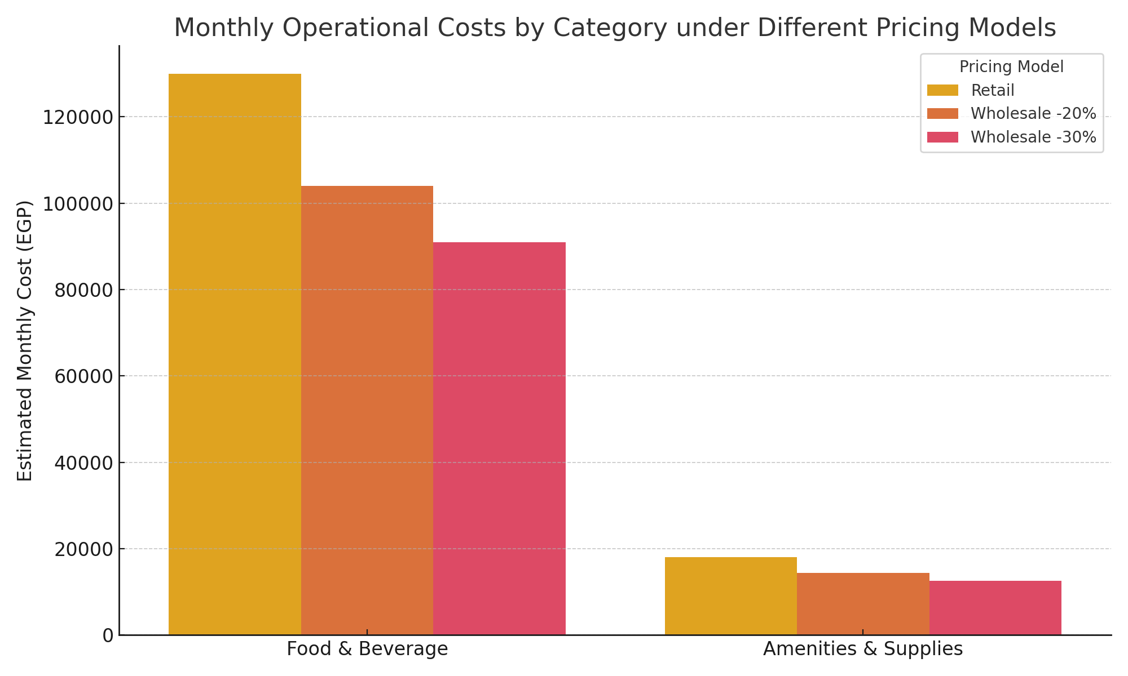

This strategic margin buffer strengthens the business model, enhances EBITDA potential, and demonstrates resilience even under high-cost scenarios.

## Hotel Amenities & Supplies Estimate

To support 10–12 guests on a weekly basis, the resort will require a combination of refillable amenities, cleaning materials, and pool maintenance supplies. This list has been priced based on retail sources (Hyper One & Amazon Egypt), assuming the worst-case cost scenario. Actual operational pricing is expected to be 20–30% lower when purchased wholesale. The monthly total for guest amenities, laundry supplies, and pool maintenance is approximately 18,000 EGP.

## Food & Beverage Cost Estimate

To support a rotating guest base and staff, the estimated food cost is based on 3-day cycles covering proteins, dairy, grains, and fresh produce. The following quantities represent retail pricing estimates gathered from Amazon and Hyper One, which act as a conservative benchmark. Final operational costs are expected to be 20–30% lower when sourcing from wholesale partners. Total estimated monthly cost for food is approximately 130,000 EGP.  
  
Breakdown for 3 Days:  
- Chicken: 10–12 kg (2,000 EGP) — mix of 6 kg breast and 4 kg thighs  
- Beef/Lamb: 7–9 kg (4,500 EGP) — includes tenderloin, kofta, entrecôte  
- Fish: 7–9 kg (1,300 EGP) — frozen fillets  
- Eggs: 100–120 eggs (450 EGP)  
- Fresh Vegetables: 18–20 kg (650 EGP)  
- Fresh Fruit: 10–12 kg (1,000 EGP)  
- Milk/Dairy: 12–15 L milk (470 EGP), 6–9 kg yogurt (300 EGP), 4–6 kg cheese (1,500 EGP)  
- Grains/Carbs: 5–7 kg (250 EGP) — 4 kg rice, 4 kg pasta  
- Oil, spices, condiments: bulk monthly estimate (4,000 EGP)

# 8. Competitive Advantage

Unique location and eco design, a trusted local partner, cultural immersion, ready infrastructure, influencer partnerships, and exclusive Hathor-powered spa make this resort a top-tier retreat venue.

# 9. Suggested Experiences & Activities

* Mr. Abdullah’s Telescope & Stargazing Night
* Natural Hot Spring Soak
* Salt Lake Plunge
* Loweesa Tea Ritual by bonfire or hot spring
* Desert Safari with Bedouin guides

# 10. SWOT Analysis

Strengths: Unique location, strong niche, Hesham’s network, Hathor spa tie-in

Weaknesses: Remote location, seasonal heat, infrastructure limitations

Opportunities: Growing wellness market, influencer travel, retreat diversity

Threats: Economic/political instability, competition, tourism sensitivity

# 11. Facilities Overview

Land, pool, kitchen, restaurant, spa, eco huts, yoga space, cold room, gift shop, and staff housing. Estimated cost: 14.7M–18.95M EGP.

# 12. Financial Forecast (3-Year Summary)

Average nightly rate: 250 USD (~12,645 EGP). 70% occupancy. 20 rooms.

Year 1 Revenue: 52M | EBITDA: 34M

Year 2 Revenue: 69.3M | EBITDA: 47.3M

Year 3 Revenue: 74.3M | EBITDA: 50.3M

# 13. Investment Ask & Use of Funds

Total needed: 19M EGP | Equity offered: up to 40%

Funds go toward land, buildout, spa, furnishings, marketing, and working capital.

# 14. Development Timeline

Month 1–2: Acquire land & permits  
Month 3–6: Construction  
Month 7: Hiring & soft launch  
Month 8: Trial retreat  
Month 9: Full launch

# 15. Contact

[Your Name]  
[Email]  
[Phone]

# 16. Financial Projections Chart

Visual chart of revenue, expenses, and EBITDA over the first 3 years.

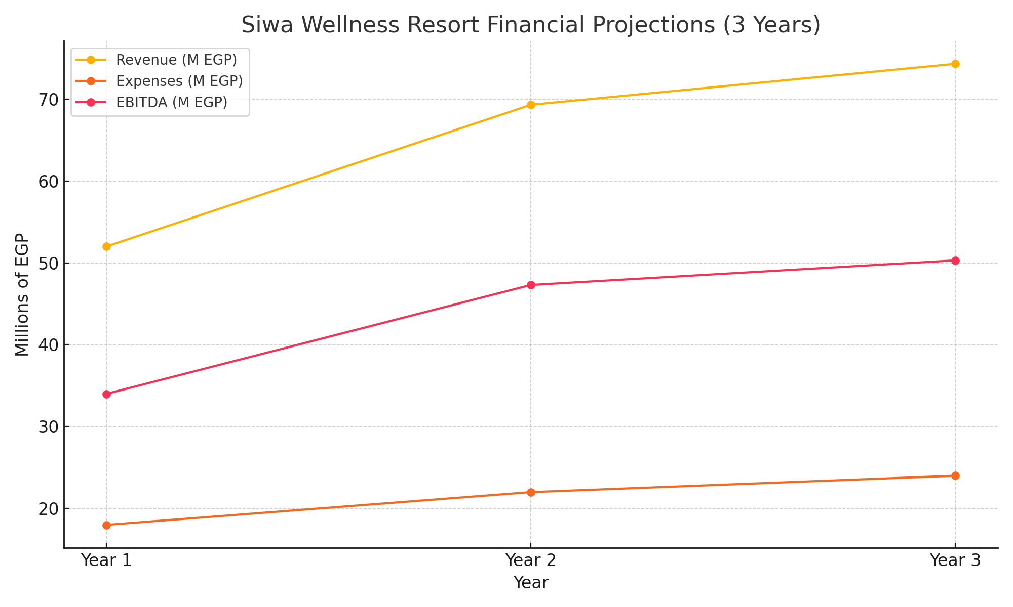

|  |  |  |  |
| --- | --- | --- | --- |
| Role | Count | Monthly Salary (EGP) | Total (EGP) |
| General Manager | 1 | 20,000 | 20,000 |
| Front Desk | 2 | 12,000 | 24,000 |
| Housekeeping | 8 | 8,000 | 64,000 |
| Kitchen Staff | 4 | 8,000 | 32,000 |
| Admin (Finance) | 1 | 12,000 | 12,000 |
| Gardeners / Janitors | 4 | 8,000 | 32,000 |
| Utilities |  |  | 20,000 |
| Total Estimated Monthly Cost |  |  | 200,000 – 210,000 |